**IST 618 – Information Policy**

**Economic Analysis Report**

**David Doman**

**Introduction**

There have been many industry disruptors due to the utilization of technology such as Uber, Lyft, Amazon, etc. Their entry into industries, that have remained somewhat unchanged for ages, has weeded out a lot of competition and put many players out of business. The disrupter I will be covering in this report is a bit different than Uber and Amazon as they have created a whole new industry. Instacart is this company as they have virtually created the grocery delivery industry. Their entry into the grocery industry has been different from those of Uber and Amazon as they have teamed up with already established grocery chains, rather than attempt to take market share from already existing grocery chains. Many competitors have attempted to follow suit in the grocery delivery area but Instacart currently remains the leader in this industry.

**Competition Issues**

There have been many newcomers to the grocery delivery industry, although Instacart holds more than 65% of the entire grocery delivery market. One noteworthy competitor is Amazon, a company that has been proven to be successful in a variety of different areas and are well known to crush competition. Amazon has many resources that other new or startup companies may lack. This would be Instacart’s main threat when considering competitors in the grocery delivery area at the current moment.

Instacart literally takes the price of products as they are offered in grocery stores and in some instances, they will markup the price of products as much as 20%. It varies as to which products are marked up due to the grocery store and the contracts they have with them. Obviously, if a company can markup products at a lower level than competitors, they will have an advantage as consumers would like to pay a price that is closest to what they would pay in the store.

Instacart has a very robust and substantial technological platform. Besides Amazon and their food delivery service, Instacart is ahead of all the other competition. This has been one of the main reasons to why they have been so successful. Their app is very user friendly and not difficult to use at all. I am not sure what new technology could be introduced that would disrupt this industry so its tough to determine how new technology could change this industry.

As it stands now, Instacart is the leader with regards to market share for this industry. Their technology has been a leading force for this success and to maintain this lead they need to continue to invest heavily in this area. If their app were to faulter or crash this would have drastic consequences to their business profitability. They have implemented guaranteed delivery within an hour, given a customer wants to pay an additional fee, which has been another big reason for their growth and success. Consumers like to know and choose when their groceries will be delivered. Living up to this standard of providing groceries within the time they promise is a big part of consumer trust in the company. Furthermore, being able to keep fees lower than competitors will also be a big part of Instacart maintaining their lead in the industry.

I believe Instacart can maintain as a leader in this industry if they continue to improve and avoid any blips in its technology or service promises. I do not think they can completely take over the entire industry as grocery store diversity is so different in certain parts of the country. Competitors can create relationships and make contracts with smaller grocery stores in certain portions of the country and keep a stronghold in these areas. In my opinion, Amazon has too many good relationships and resources to be completely shut out of the industry.

**Costs**

Instacart’s business model is very scalable and efficient. There are two main fixed costs for Instacart. The first being the cost of insurance for business operations. Rates will increase year over year, but this is a set fee that will not change for the current year. The second fixed cost for the company is salaries for permanent full-time employees. Since they do not have rent or inventory storage/management concerns the rest of their costs are variable. To maintain their technology platform, they must pay a fee for this. This cost is sort of a mix between being variable and fixed. If demand increases, the cost of scaling the capability for their platform to keep running smoothly will increase as well. Although, if demand decreases, this will still be a cost incurred so it becomes more of fixed cost. A variable cost for Instacart includes commissions for their shoppers. This cost is solely based on if demand increases or decreases.

**Demand & Prices**

There are various factors that affect demand for this service, some more typical and others more unforeseen. First, having access to the same type of groceries on the app that a consumer would have access to in the physical grocery store will increase demand. Next, making sure groceries are delivered in the time frame promised by Instacart will build customer trust and loyalty, which will in turn increase demand. Another common factor for many industries is keeping costs as low as possible and not drastically higher than what a consumer would pay in the physical store. If the service and delivery fees are worth it to the consumer (i.e., worth the time spent driving to the store and shopping in the store themselves) this will drastically affect demand for the product. A final factor that is unforeseen and we have experienced more recently is the COVID-19 Pandemic. This has driven demand for the service much higher as more people are avoiding public places.

Since this is such a new experience in the grocery industry, Instacart has brought new customers in by offering free delivery for new customer’s first order. I know this promotion is what brought me to try the service. Furthermore, advertising on social media outlets, such as, Twitter, Facebook, etc. have been substantial ways they have reached out to potential customers. Word of mouth has been successful for Instacart as many customers have found the service to be very convenient, reliable and time saving.

Instacart makes money in a couple of ways. Instacart utilizes mark up prices on certain products, not all of them, by as much as 20%. Any revenue earned from the mark up goes directly to Instacart and not to the grocery stores. Another source of revenue comes from delivery fees, which increase if you would like your groceries delivered sooner and are less costly if the consumer is willing to wait longer for their groceries to arrive. Another source of revenue, which is used by companies like Uber and Lyft, is surge pricing. Instacart uses a dynamic pricing algorithm to increase the delivery charge as demand for that delivery time slot increases. Service Fees & Tips are another source of revenue and these apply to every order placed. Even the tip for the shopper is set at a minimum of 5% with the ability for the customer to increase this amount if they would like. Instacart also offers an annual subscription plan, which can cost upwards of $100 per year. This membership fee has varied over time and has been as high as $149 per year. The benefit of the subscription plan is unlimited free delivery on every order of $35 or more and savings on fees during busy hours. The final source of how Instacart makes money is the revenue from their grocery store partners. Kroger, Food Lion, and many other grocery stores alike pay Instacart per-order-profits and commissions. The stores are comfortable paying this as Instacart’s platform drives customers to their stores.

Instacart’s main goal is to make grocery shopping more convenient and efficient for consumers. They do this by allowing consumers to shop from the comfort of their home on their smartphone or computer.

If a Groupon style sale were to occur for Instacart it would mainly be focused on getting soon to expire products off the shelves of stores. They could lower the price of these products if they were marked up to increase demand.

The demand for this service is very elastic. If fees become too expensive that they outweigh the consumer just going to the store themselves, then demand will drop substantially. If the consumer feels that the fees are worth the time spent by them going to the store themselves the service will succeed. Small changes in price will have drastic changes in demand, in other words, this service is not something most people feel as a necessary service. Shown below is a general idea of the demand curve I believe Instacart possesses when looking at price:

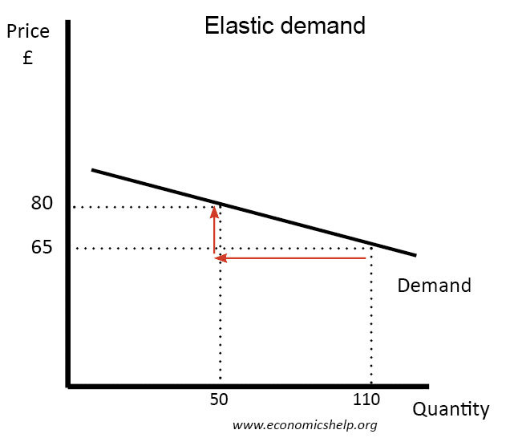

As for substitutes, if the consumer cannot get the brand of a product they like, this could decrease demand for the service. A big reason Instacart has had so much success is because they can almost completely mimic what a consumer would buy themselves in store. If they started only offering grocery store brands of products that idea of mimicking purchases made in-store would be diminished and the service would suffer. Since Instacart offers what stores offer, providing complement type deals, such as, a deal on peanut butter and jelly bought together for a discount, these deals would be determined by the grocery stores and not in Instacart’s control.

The company has recently moved into different areas such as retail stores. I personally do not think this a good idea as expanding to such stores almost brings the company into competition with Amazon. I believe Instacart should solely focus on the grocery delivery industry and work to ensure that they are putting all their resources there to make sure they are providing the top service for groceries. Expanding to fast into other areas could be detrimental to the future success of the company.

**Conclusion**

In conclusion, Instacart is in a good position to continue to be successful and increase their market share within the grocery delivery industry. While competition will appear, if they stay true to what they have been doing so far, they should be in a good spot to keep most of the market share. Again, their technological platform is the most important aspect of Instacart’s success, so this is a vital part to profitability in the future for this company.